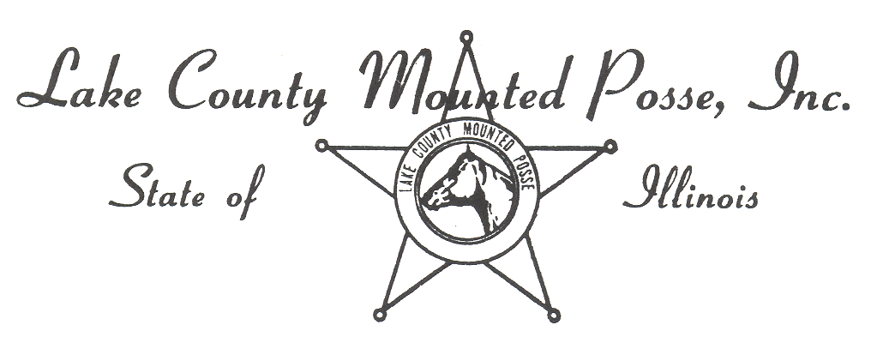
Lake County Mounted Posse Associate Requirements & Log
Name: __________________________ Sponsor: _________________________
- Complete membership renewal/associate application, release form, and pay associate membership fee.
- Attend at least one (1) general membership meeting during their associate year*.
- Assist with the “Associate Members Play Day”, if one is scheduled.
- Assist with the annual Horse Show, if one is scheduled.
- Attend at least three other events.
- Apply for full membership no later than the March membership meeting following the Associate Year*.
- Pay dues within 30 days after being notified by the President of acceptance as a full member. If not paid within the 30 day limit, the associate member will be dropped from the membership rolls without further notice.
SUMMARY: Six appearances required of an Associate Member in the year of associate membership.
Associate Activity Log
Indoor Meetings Attended: 1: ___________________ 2. ___________________
Associate Play Day Activities You Assisted With: ____________________________________________________________________________________________________________________________________________________________
Other events you participated in (Other than Associate Play Day): ____________________________________________________________________________________________________________________________________________________________
Horseback events you attended: ____________________________________________________________________________________________________________________________________________________________
Please return this form to the club secretary no later than the November general meeting.

