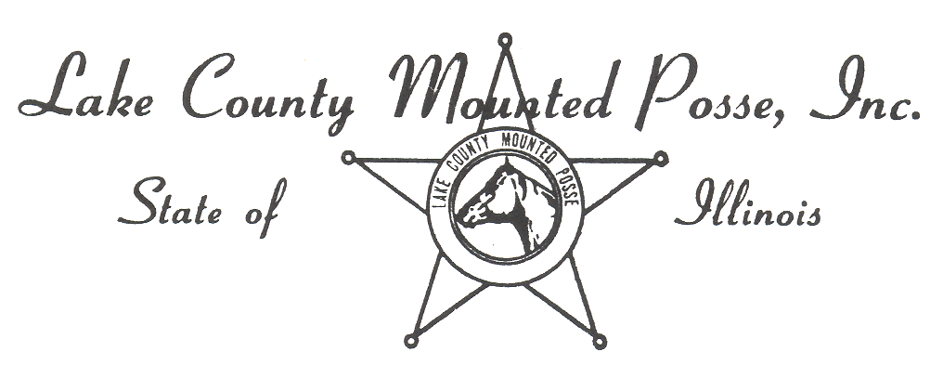
2023 Horse Show Sponsor Form

Sponsorship Type – Circle one
- Silver (under $100.00)
- Gold ( $101.00 to 199.00)
- Platinum ($200.00 and over)
- $___________________
  - Any amount that you would like to donate to our show.

Sponsor Name____________________________________________________________________.

Message for announcer to read at the show: (Business card or brochure or separate sheet.) _______________________________________________________________________________________________________________________________________________________________________________________________________________________________________________________________________________________________________________________________________________________________________________________________________________________________________________________________________________________________________________________________________________________________________________________________________________
LCMP Member Sales Person: ________________________________________________________________________________
*We will try to get all of the Platinum sponsors names on the show bill but there is a limited amount of space so it will be first come first served. Your sponsorships will be listed and displayed for the show and the announcer will read your ads through out the day. Feel free to send business cards and brochures as we will be happy to put them out for people to take.
_ _ _ _ _ _ _ _ _ _ _ _ _ _ _ _ _ _ _ _ _ _ _ _ _ _ _ _ _ _ _ _ _ _ _ _ _ _ _ _ _ _ _ _ _ _ _ _ _ _ _ _ _ _ _ _ _ _ _ _ _ _ _ _ _ _ _ _ _ _ _ _
Donation Amount $ ________________________
Name of Donor _______________________________
Date of Donation _____________________________

