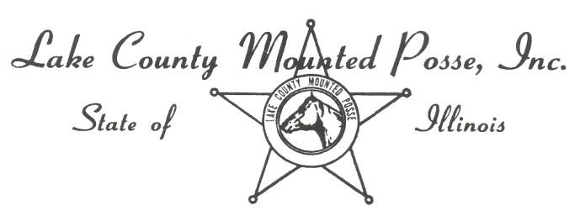
2024 Horse Show Sponsor Form

Sponsorship Type – Circle one
- Silver (under $100.00)
- Gold ($100.00 to 199.00)
- Platinum ($200.00 and over)
- $___________________
o Any amount that you would like to donate to our show.

Sponsor Name____________________________________________________________________ .

Message for announcer to read at the show: (Business card or brochure or separate sheet.)
______________________________________________________________________________________________________________
______________________________________________________________________________________________________________ ______________________________________________________________________________________________________________
______________________________________________________________________________________________________________ ______________________________________________________________________________________________________________ _________________________________________
LCMP Member Sales Person: ________________________________________________________________________________

*We will try to get all of the Platinum sponsors names on the show bill but there is a limited amount of space so it will be first come first served. Your sponsorships will be listed and displayed for the show, posted on our Facebook page and the announcer will read your ads throughout the day. Feel free to send business cards and brochures as we will be happy to put them out for people to take.

MAIL SPONSOR FORM AND CHECK made payable to LCMP to: LCMP Treasurer, c/o Ghislaine deKoning, 13150 W Townline Rd, Waukegan, Illinois 60085
_ _ _ _ _ _ _ _ _ _ _ _ _ _ _ _ _ _ _ _ _ _ _ _ _ _ _ _ _ _ _ _ _ _ _ _ _ _ _ _ _ _ _ _ _ _ _ _ _ _ _ _ _ _ _ _ _ _ _ _ _ _ _ _ _ _ _ _ _ _ _ _
Donation Amount $ ________________________
Name of Donor _______________________________

Date of Donation _____________________________

